SHOPSY E-COMMERCE DATABSE MANAGEMENT
SYSTEM
SELLER AND INVENTORY MANAGEMENT SYSTEM
1.Database Design :
The ShopSphere Online E-Commerce Database Management System uses Seller, Product, and Inventory as important entities for managing sellers, products, and stock available on the e-commerce platform. The Seller table stores information about different sellers, while the Product table stores product details such as product name, seller ID, category ID, price, stock, and description. The Inventory table stores available stock and last updated information for each product. The Product table is connected to the Seller table using Seller_ID, and the Inventory table is connected to the Product table using Product_ID, which establishes one-to-many relationships between the related tables.
1.1 Seller Table :
Attribute | Key Type
Seller_ID | Primary Key
Seller_Name | Not Null
Email | Unique Key
Phone | -
Address | -
1.2 Inventory Table :
Attribute | Key Type
Inventory_ID | Primary Key
Product_ID | Foreign Key
Available_Stock | -
Last_Updated | -
2. Relationship :
Seller → Inventory
- Seller.Seller_ID → Primary Key
- Inventory.Inventory_ID → Primary Key
- Inventory.Product_ID → Foreign Key referencing Product.Product_ID
- Relationship: One-to-Many (1:M)
- One seller can have multiple inventory records.
3. Table Creation :
3.1 Create Seller Table :
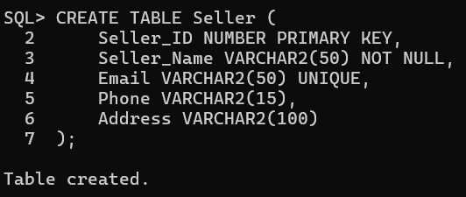
3.2 Create Inventory Table :
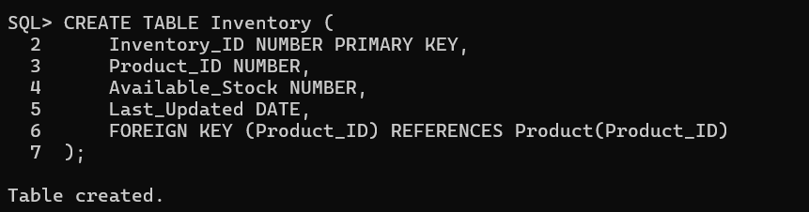
4.Data Insertion :
4.1 Seller Records :
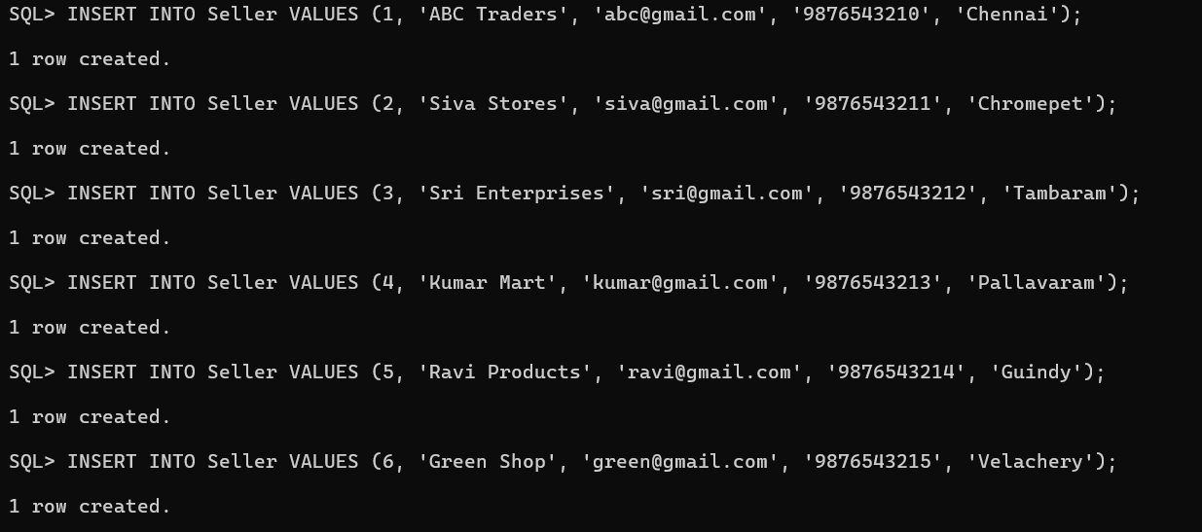
4.2 Inventory Records :
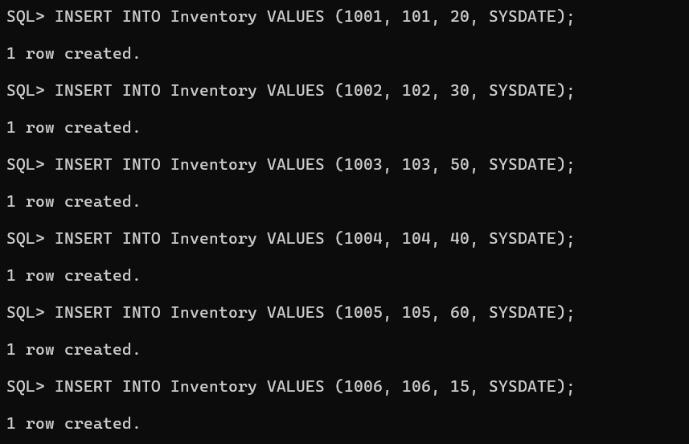
5. Data Retrieval :
5.1 Display Seller Records :
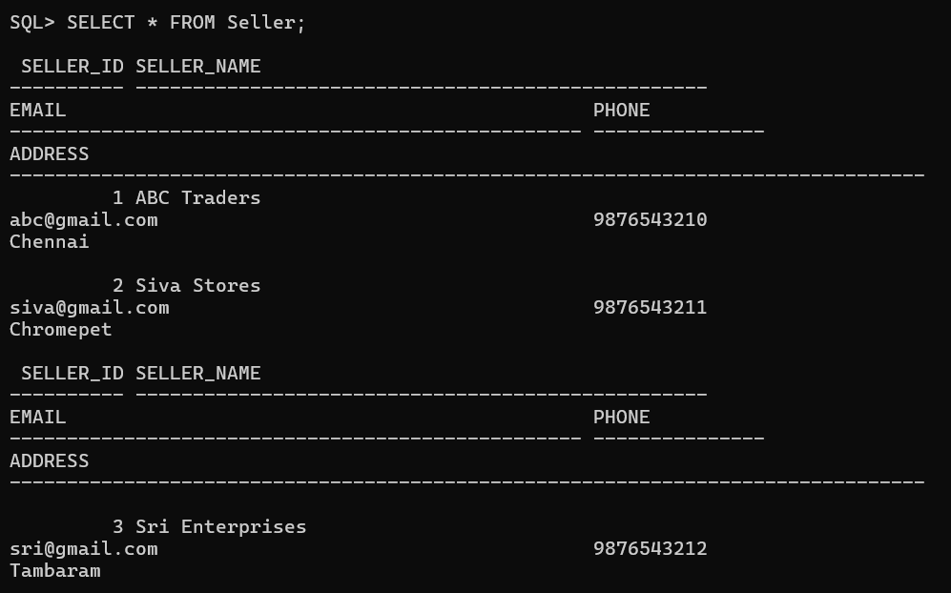
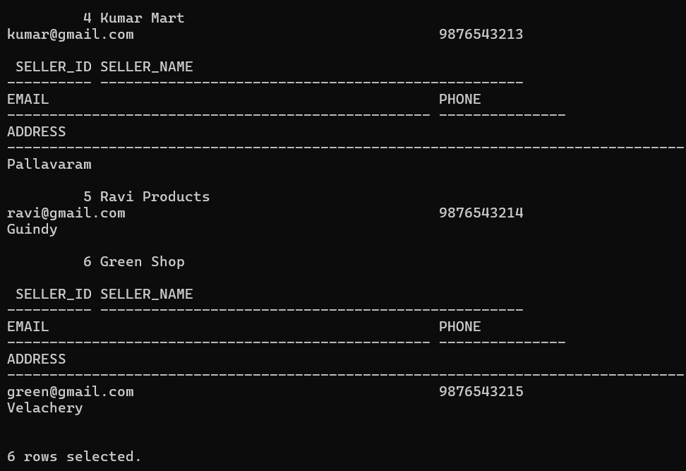
5.2 Display Inventory Records :
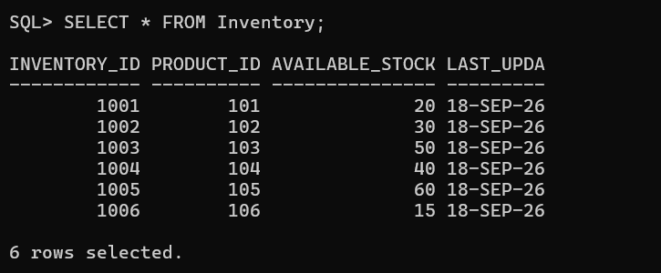
6.Seller Product Information :
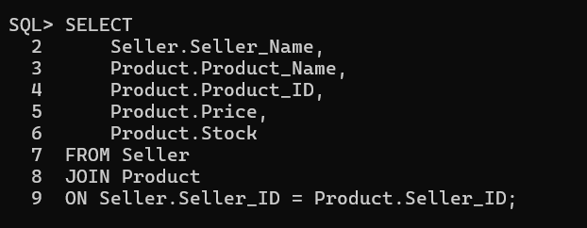
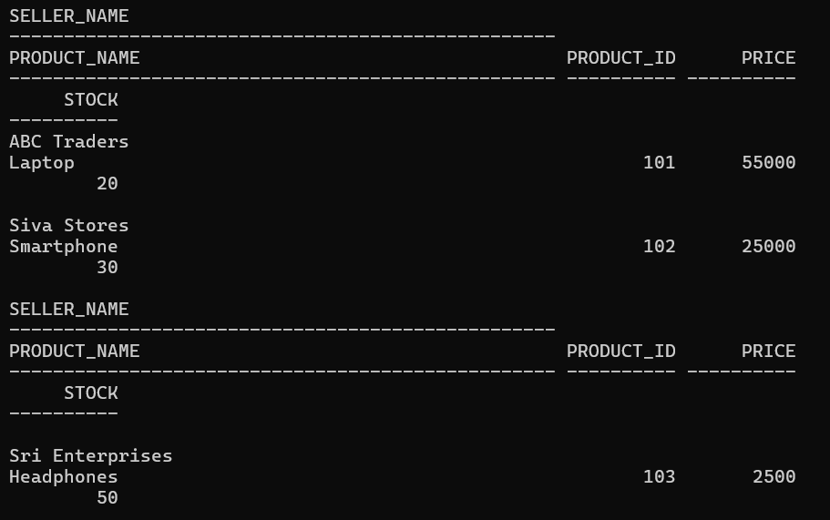
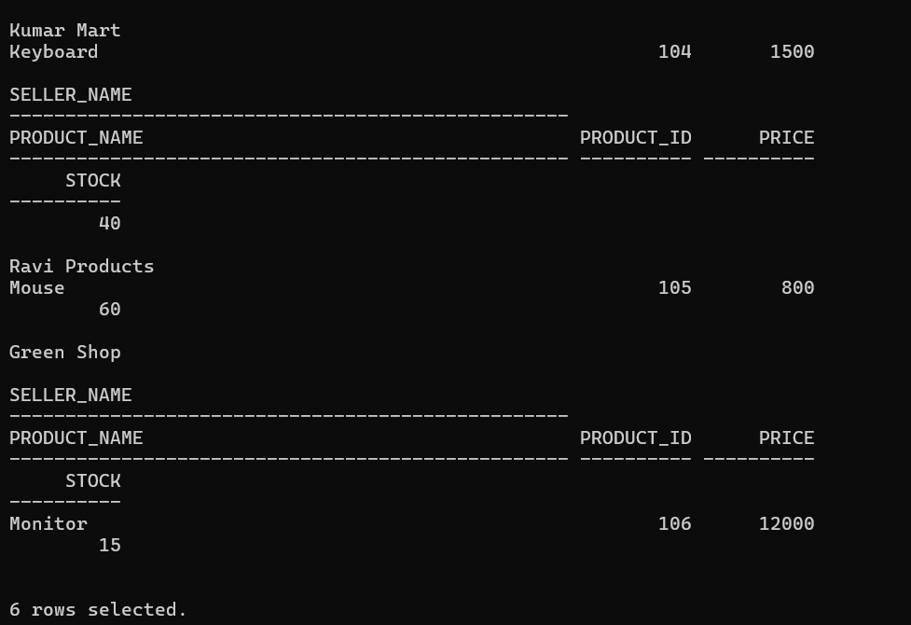
7. Product Availability :
7.1 Available Products :
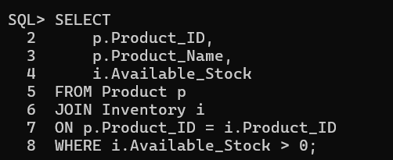
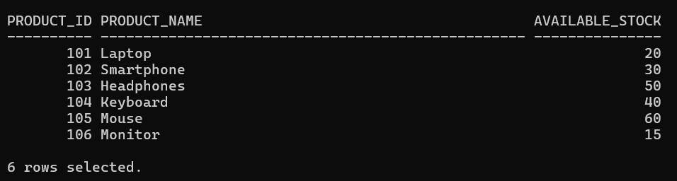
7.2 Unavailable Products :
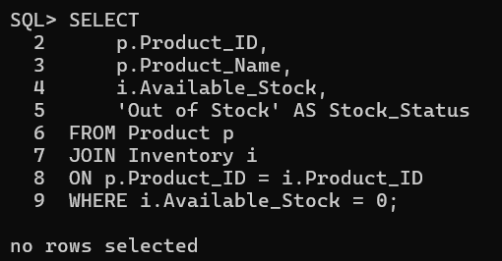
8. Inventory Update :
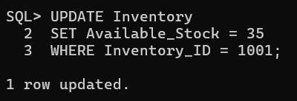
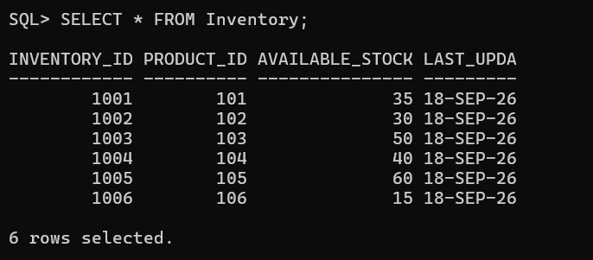
9. Inventory Status Reports :
9.1 Complete Inventory Report :
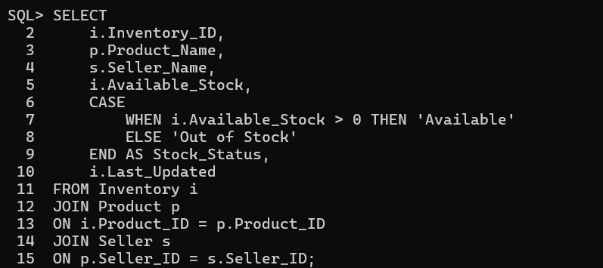
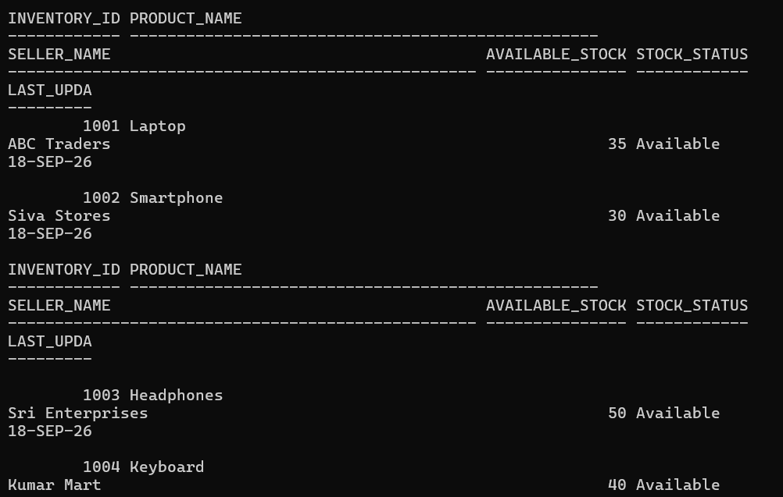
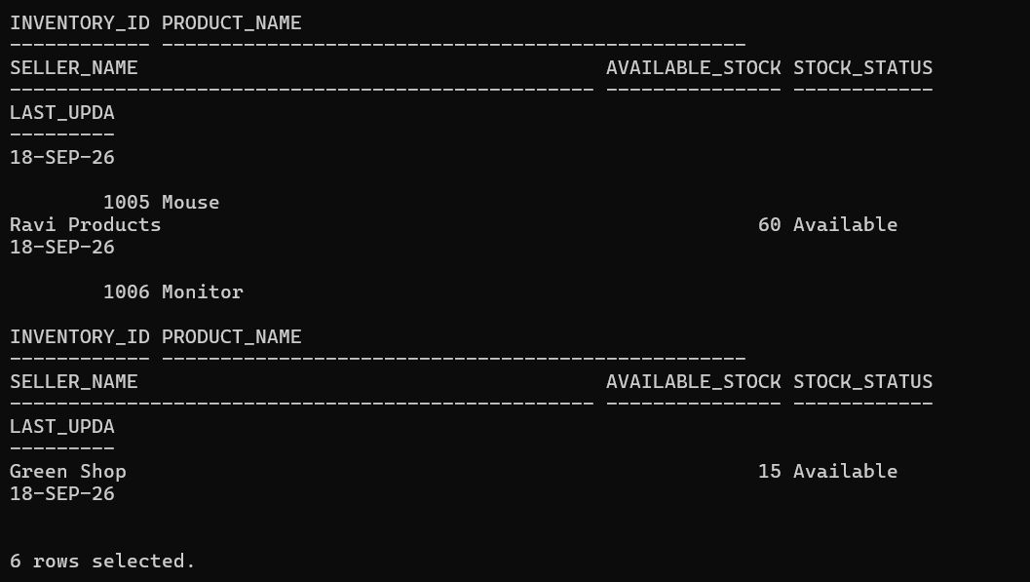
9.2 Total Stock by Seller :
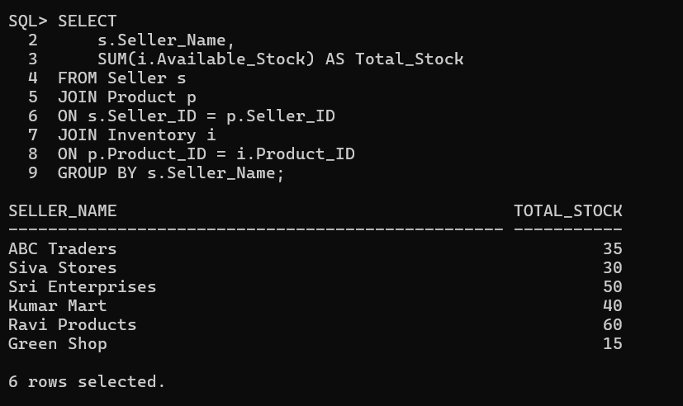
9.3 Available and Unavailable Product Count :
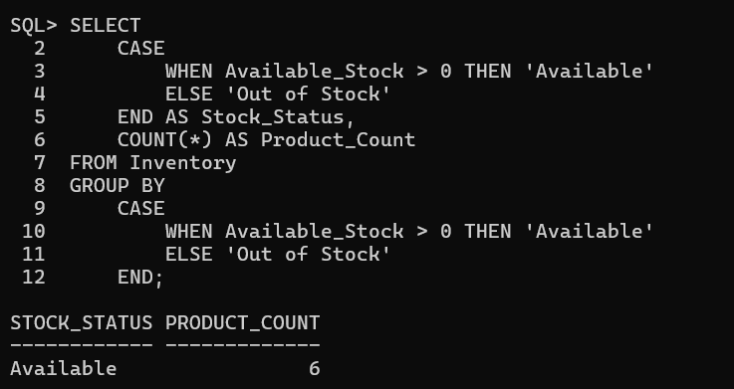
Conclusion :
The ShopSphere Online E-Commerce Database Management System successfully manages seller, product, and inventory information using SQL. The system uses primary keys and foreign keys to establish relationships between the related tables. SQL operations such as CREATE, INSERT, SELECT, JOIN, UPDATE, and DELETE are used to manage the data. The system also helps to maintain available stock information, identify unavailable products, and generate inventory status reports. Overall, the database provides an organized way to manage seller, product, and inventory details in the e-commerce platform.

